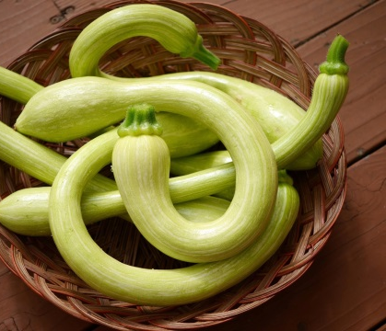
Trombetti Di Albenga Italian heirloom summer squash. Vigorous climbing vine, producing many 12 to 15 inch, lime-green fruits with a curvaceous trumpet shape and a delicate mild taste with a hint of nutty artichoke flavor. Trombetta’s flesh is seedless and firm and doesn’t get watery or mushy like regular zucchini. The rambling plants will soon cover a trellis, fence or stakes with fruits that hang like ornaments cloaked in a lush canopy of big, heart-shaped leaves.
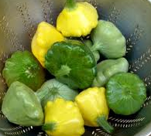
Tricolor Pattypan Mixed seed packet so plants will be one of delicious different pattypan squashes: Buttercup-yellow fluted “Sunburst” is tender and nutty tasting simply steamed or poached in broth. Dark green, glossy little “Starship” has zucchini color and flavor in a unique flying saucer shape. Pretty apple-green “Peter Pan” scallops are creamy and sweet fleshed – a treat to sauté or slice and grill.
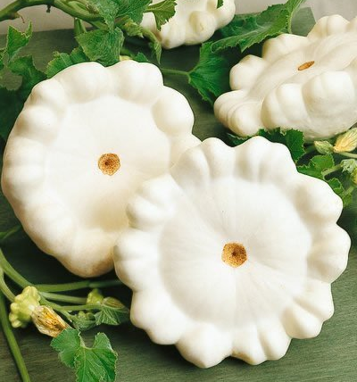
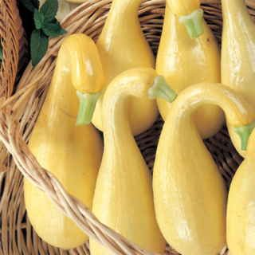
Sunny Supersett Crookneck Squash Butter-yellow Supersett have fine-textured flesh and sweet nutty flavor typical of tender crookneck squash. This glossy, thin-skinned hybrid reliably out-yields older varieties, bearing an abundance of smooth, bright yellow squash with delicate, creamy flesh. The open bush plants have excellent mildew resistance, few spines, and the fruits have strong necks that won’t break when harvested. Sunny Supersett begins bearing early, so you’ll have a long summer season of enjoyable meals with these old-fashioned favorites.
Early White Bush Scallop An ancient variety that can be traced back to 1591. Deeply scalloped, pale green, pie-shaped fruits measure 7 inches across by 3 inches deep and turn creamy-white. Flesh is milky-white, firm and tender with a mild, sweet flavor. Very productive closed bush plants. Also called White Patty Pan.

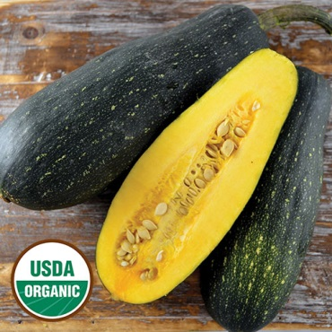
Dostal Cucumber Squash Donated to SSE by Arthur Dostal. A variety grown by his parents, Lewis and Mary Dostal of Tama Co., Iowa, who reportedly received it from family friends. Begins as cream-white and green, maturing to dark green. Sweet flavor with buttery smooth texture when grown as a winter squash, but also delicious as a summer squash. 90 days.

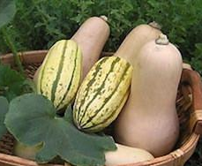
Early Butternut and Delicata Duo seed packet, so plants are one of two varieties, both All-America winners. Space-saving varieties of nutty, sweet-tasting, vitamin-rich winter squash. The compact vines of productive Early Butternut Bush produce fruits with tan rinds that have moist, smooth, creamy-orange flesh. Compact Bush Delicata has oblong fruits with handsome striped rinds and rich golden flesh with a delicious sweet potato-like texture.
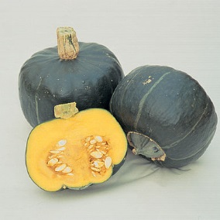
Burgess Buttercup Delicata The standard buttercup squash. The medium-small, 3-5 lb., fruits have deep-orange, fiberless flesh with a rich, sweet flavor. A northern New England favorite. Avg. yield: 3-4 fruits/plant. Organically grown.

